**Problem 01:**

**Scenario:**

Consider a showroom with a class named “car” under it comes different objects (cars for display). Class attributes will remain same throughout and the cars (objects) within this class will vary. Methods for these cars (objects) will remain same. In this context, each car object will have its own model, year of manufacture, color, top speed, engine power etc. Start, move, speed are some of the methods under this class.

**Class Diagram:**

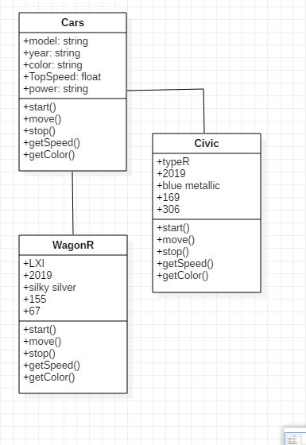

**Generated Codes:**

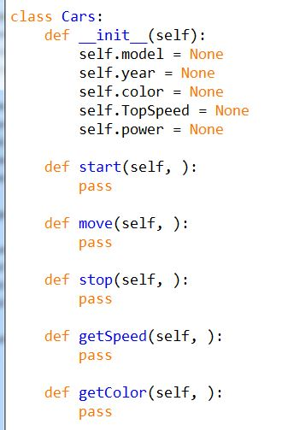

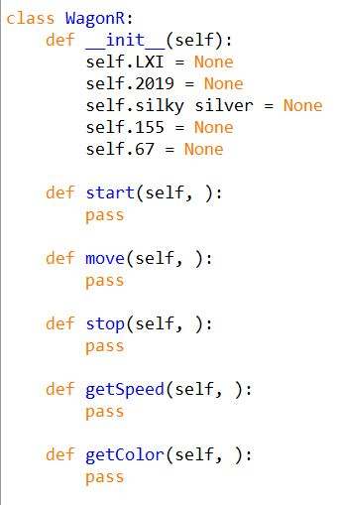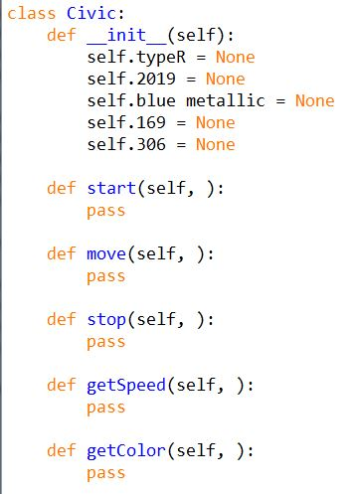

**Problem 02:**

**Scenario:**

Consider we have a police station management system. A complainant will register complain then a FIR will be filed. In FIR all the details are compiled for the case (Incident) and then it is reported to a Police officer for further investigation. After investigation the accused will be prisoned or fine depending upon the case and the case will be closed.

**Class Diagram:**

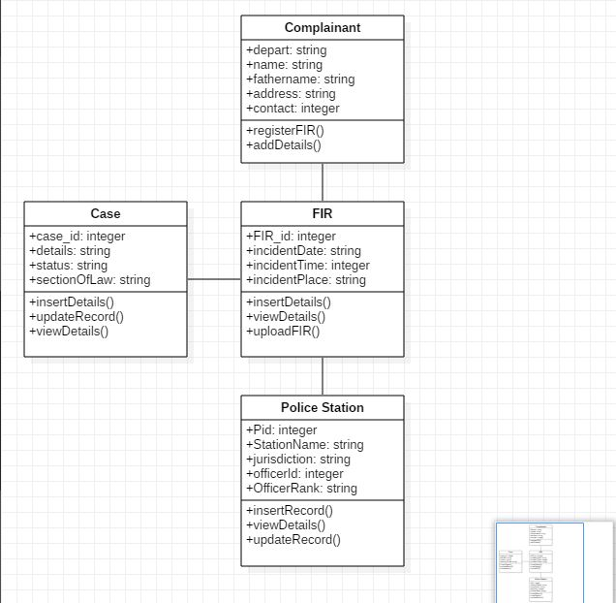

**Generated Codes:**

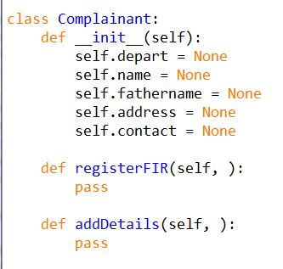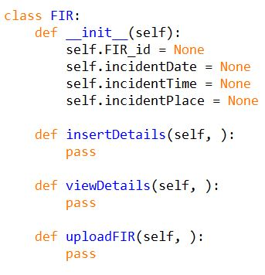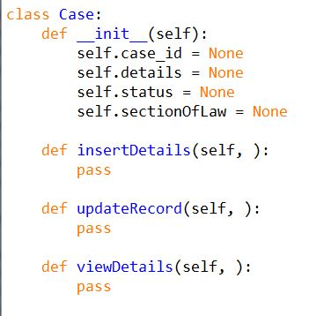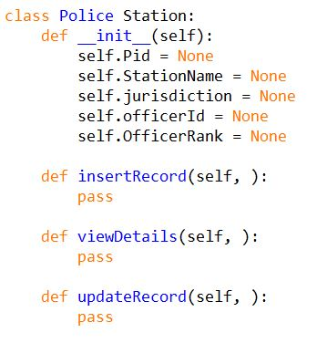

**Problem 03:**

**Scenario:**

Consider we have a gym management system. A gym management system includes information and details about every client, staff, machines (expenses). Each client will be categorized according to their packages and each client will also have their own unique id (for packages and reservation).

**Class Diagram:**

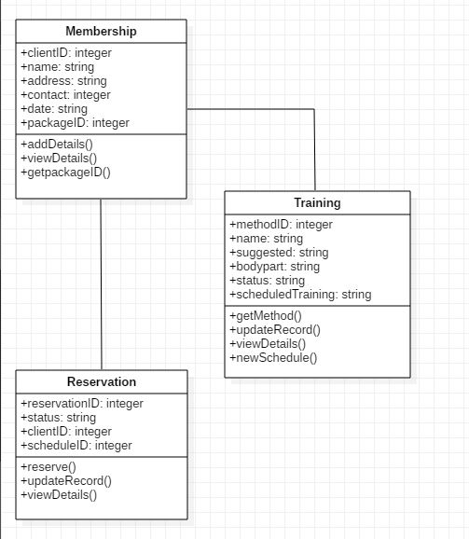

**Generated Codes:**

